Newsletter n°9 – October 2020

To present the results of the practical researches led by the partners of the CLASH! Project – Balletto di Roma (IT), 420PEOPLE (CZ), Art Link Foundation representing Derida Dance Centre (BG), Companhia de Dança de Almada (PT), Polski Teatr Tanca (PL) and Sapienza University of Rome (IT), the CLASH! eBook was officially published in September 2020. It aims to continue the development of a Professional Empowerment Strategy and to face together the issues coming from the three-macro areas of the project: Dancer’s Training; Audience Development; Marketing and Communication. Furthermore, the Clash! International Festival program is getting more rich and fruitful to all stakeholders – from dancers and choreographers, through researchers and teachers, to common audience and institutional bodies.
Presentation of CLASH! Project eBook November 14th, online
On November 14th, at 4.00 pm, the online presentation of the eBook will be held (to follow the event, please follow the link shortly available on the project website: http://clashproject.eu/).
The event will see the participation of the team of researchers from La Sapienza University of Rome (Vito di Bernardi, Letizia Gioia Monda and Luca Ruzza) who will talk with the representatives of two project partners: Ana Macara (Companhia De Dança de Almada) and Atanas Maev (Derida Dance Center).
The presentation will take place in English.

The eBook represents an important result of the investigations performed in the last two years by the five dance companies involved in the initiative. It is an interdisciplinary product created by a team of scholars from the Sapienza University of Rome, project partner responsible for the articulation of the tacit knowledge from dance practice and its translation in a language accessible to a wide audience.
Directed by Vito Di Bernardi (full professor of History of Dance), the team of scholars is composed by Luca Ruzza (professor of Graphic Electronic and Digital Arts) and Letizia Gioia Monda (adjunct professor of Digital Choreography).
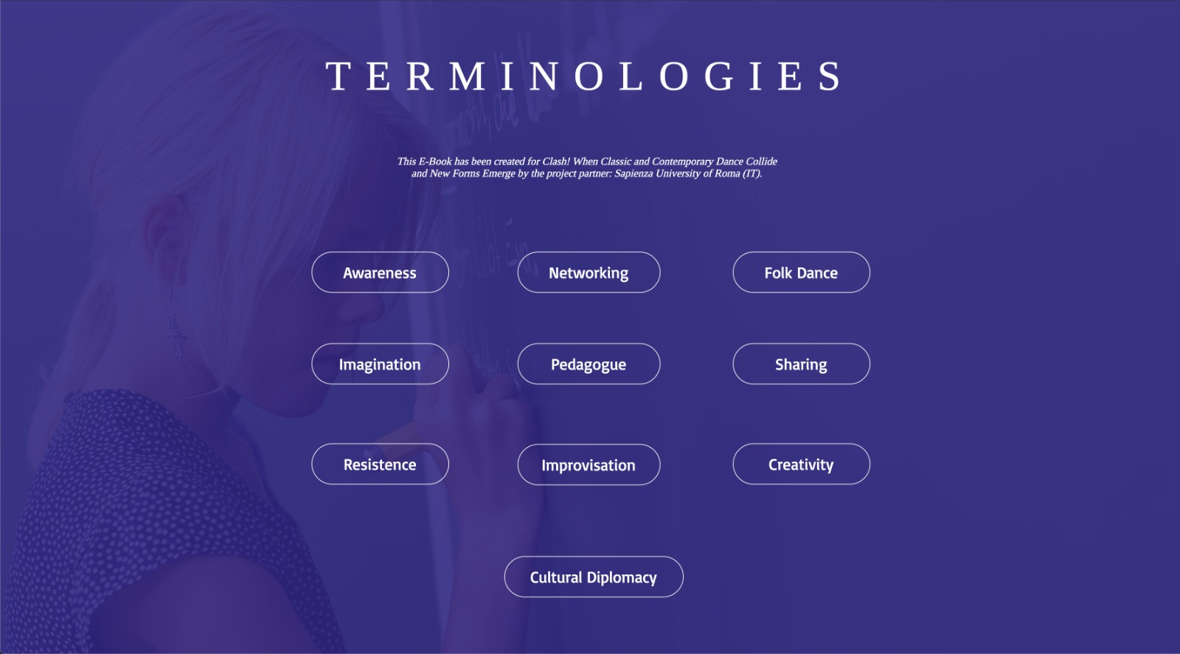
The eBook was projected as a digital platform to combine written content with images and videos. It provides an open source tool for users to transversally explore the systems developed by the partners to put in dialogue several models of dance expressions, from classic to the contemporary.
The experimentations began from the application of the Clash! Professional Empowerment Strategy, a methodology elaborated by Vito Di Bernardi and Letizia Gioia Monda to lead the five dance companies to enquire into their own daily practices and face issues related to the Dancer’s Training, the Audience Development, the Marketing and Communication systems.

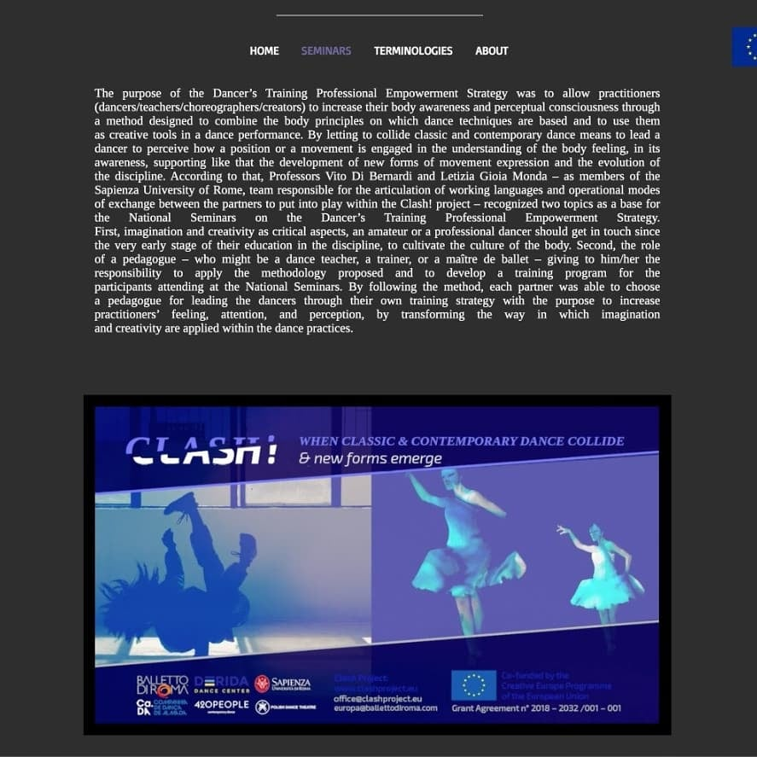

Those strategies have been put into play along 16 Clash! National Seminars. The internal reports and the feedback from the participants at the seminars have been collected, analysed, and processed to become part of the eBook contents.

For any session, it is possible to compare the starting method with its variables, or rather the specific strategies developed by each partner on any single theme. By following the eBook structure, users are able to identify solutions or compare problems the partners recognized along their research paths. In the section “terminologies” a glossary of 10 keywords is proposed to help to contextualize how partners realized the Clash! between tradition and innovation in the dance field, and to examine the knowledge coming from this experience.

Edited by Letizia Gioia Monda, the eBook has been created thanks to the collaboration of the designer Natan Andrea Ruzza and of the videomaker Chiara Crupi.

The Hybrid Festival
The event Clash! International Festival. The Hybrid in Dance Models, between Classic and Contemporary is conceived to present the results of the practical researches led by the partners of the project Clash! When Classic and Contemporary Dance Collide and New Forms Emerge, co-founded by Creative Europe Program of the European Union.
It will be a unique online digital festival performed long six days, from the 8th to the 13th of December 2020. Each festival day will be held by one of the 5 dance companies involved in the project (420PEOPLE, Balletto di Roma, Companhia de Dança de Almada, Derida Dance Centre/Art Link Foundation, Polish Dance Theatre) and will focus on a particular issue explored along the initiative. The topics such as Audience Development, Dancer’s Training, Cultural Diplomacy in the dance field and Choreographic-Making Processes will be displayed during the event programmed to allow the users to interact in creative dialogues with choreographers, dance pedagogues, and keynote speakers. Each day of the festival will end with a screendance performance created for the occasion by each partner. The team from the Sapienza University of Rome will coordinate the event.

In order to reflect together on the impact, the pandemic had on the performance field, the last day of the festival will be dedicated to open a ground to exchange visions on the role digitization can play to preserve the actualization of dance activities, and on the funding opportunities European programs will provide to sustain dance practitioners. Finally, a videodance work created by team from the Sapienza University of Rome will be streamed, on the hybrid creative processes the partners performed to adapt their analogical practice into digital artefacts.

Partner’s activities
A round table on “Creative Europe and choreographic production” by Companhia de Dança de Almada was conducted on 10th of October 2020 in Fórum Municipal Romeu Correia – Pablo Neruda Room. Ca.Da. brought together a group of international participants and stakeholders to present the Clash! Project as an example of the Creative Europe program supporting dance production, and discussing the importance of the program.
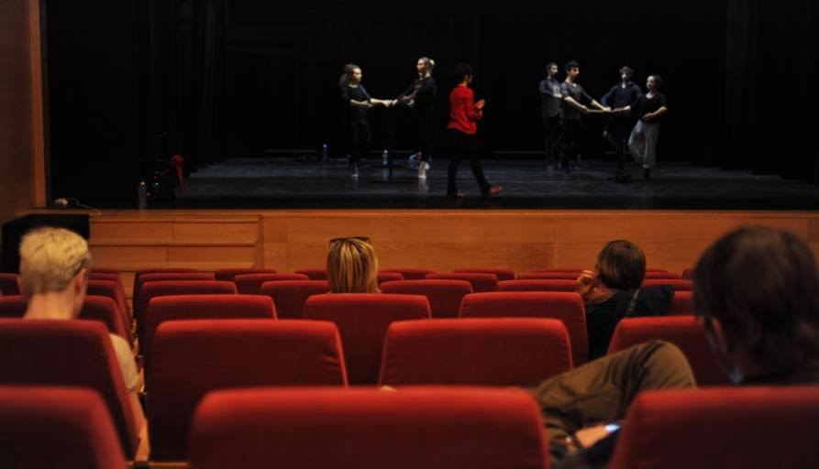

Preparation process of Polish Dance Theatre has begun in order to create an unique screendance performance for the Hybrid Festival. The company is working with Davide Valrosso – a guest choreographer at Balletto di Roma (BdR). He came to Poznan as part of the exchange of choreographers within the CLASH! Project. He worked with three of the Polish Dance Theatre’s dancers: Jerzy Kaźmierczak, Zbigniew Kocięba and Agnieszka Jachym, who in February this year studied her concept of choreography with BdR dancers.
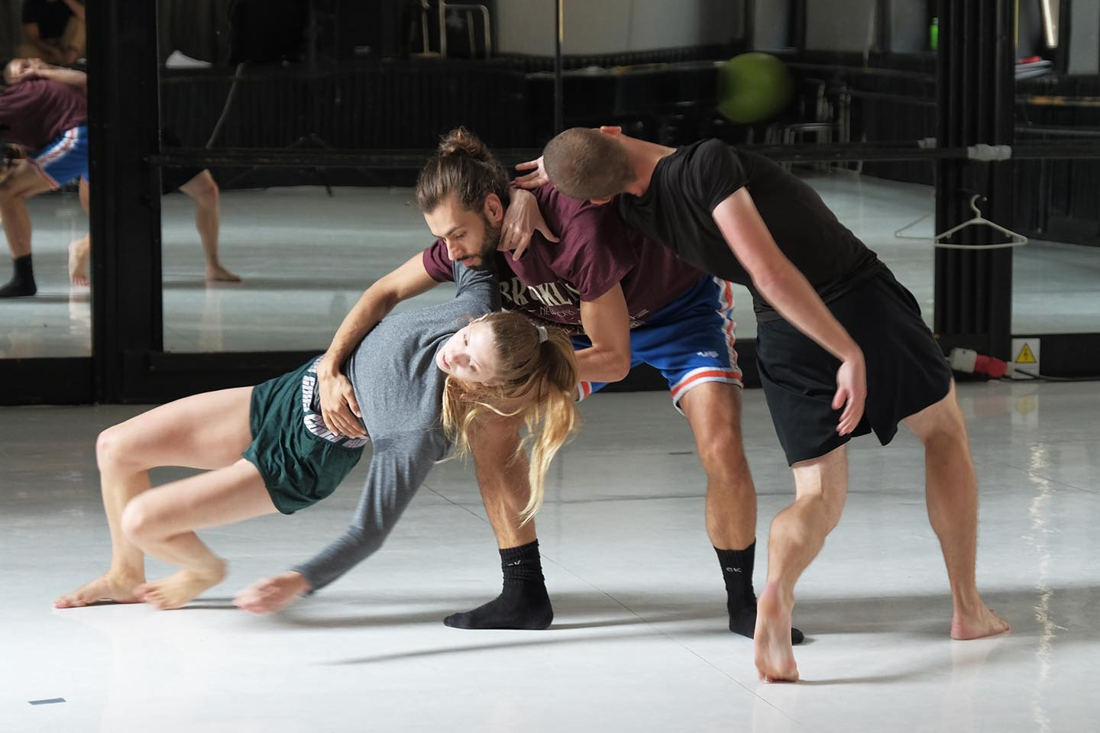

Stay tuned!
Are you interested in following the project results? Do you want to know more about the project and participate our activities?
Find us on Facebook and don’t miss our posts! https://www.facebook.com/clashprojecteu/ or visit our website: www.clashproject.eu
Contacts:
Matteo Carratoni, Balletto di Roma scarl:
e-mail: comunicazione@ballettodiroma.com, tel + 39 06 9032762
Milena Videnova, Art Link Foundation:
e-mail:milena@cim.bg, tel +359 884 276 422

In compliance with EU General Data Protection Regulation (GDPR) that came into effect on 25 May 2018, we hereby inform you that the personal data you provide to CLASH is included in a file managed by BALLETTO DI ROMA (Piazza San Giovanni Battista de La Salle 3/5 – 00165 Roma) as Data Controller, on behalf of the – EU funded project – CLASH's partners, and used exclusively for dissemination of professional communications, newsletters, events or promotions related to contemporary dance, organized directly by any of the CLASH! partners or by carefully selected third parties pursuing a wider understanding and promotion of Contemporary dance in Europe or abroad.
You may revoke the consent you have given us at any time; Likewise, you may exercise your rights of access, rectification, cancellation and opposition free of charge by sending your request accompanied by the copy or data of your Personal Number to the telephone number 00 06.90375236 email privacy@ballettodiroma.com or the address BALLETTO DI ROMA, with VAT Number (p.iva/cod.fisc.) 11205521005.
In order to view our privacy policy and/or information about your Personal Data, the purposes and the parties the Data is shared with, visit the website http://clashproject.eu/privacy/ or contact with comunicazione@ballettodiroma.com

